35. Create a HTML web page, change the position of the element relative to the parent
element and relative to itself using relative positioning with a CSS file. Also display the
same elements with absolute positioning with difference.
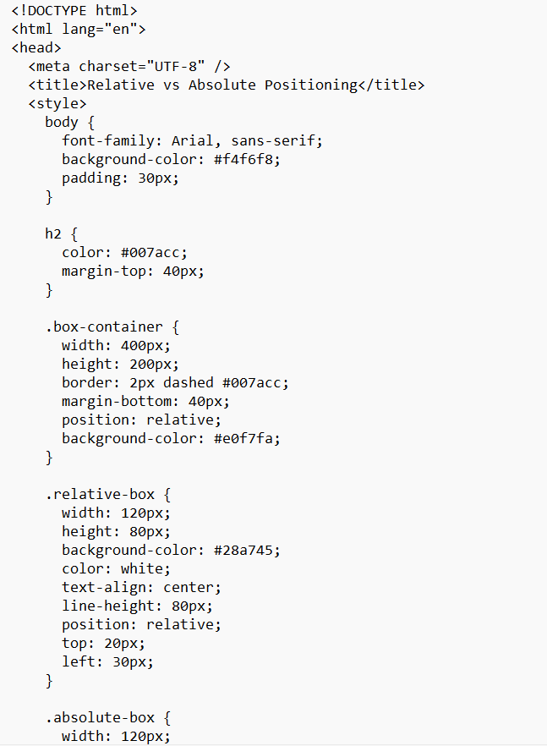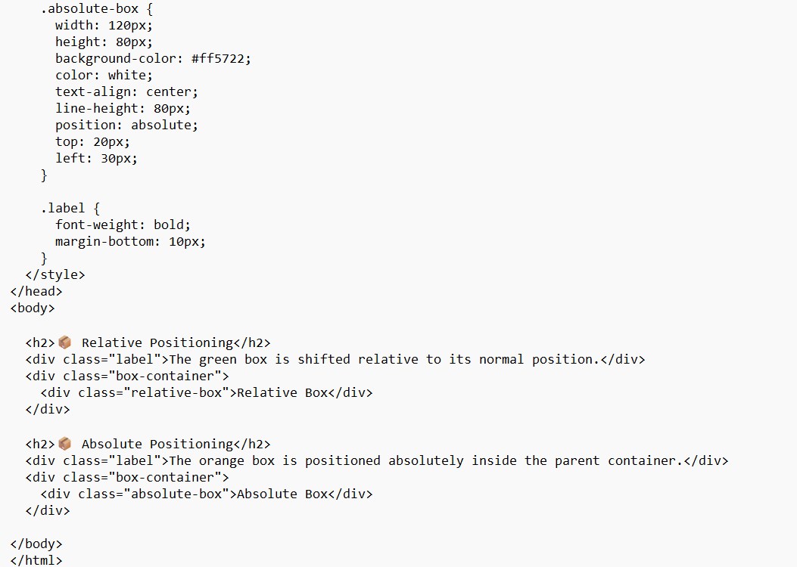output
